**Cloud Computing Write-up**

**Dhruv Harchandani A005**

**1) Cloud Computing Architecture :-**

Cloud Computing technology is used by both small and large organizations to ****store the information**** in cloud and access it from anywhere at anytime using the internet connection.

Cloud computing architecture is a combination of service-oriented architecture and event-driven architecture.

Cloud computing architecture is divided into the following two parts -

1. Front End
2. Back End
3. Front End

The front end is used by the client. It contains client-side interfaces and applications that are required to access the cloud computing platforms. The front end includes web servers (including Chrome, Firefox, internet explorer, etc.), thin & fat clients, tablets, and mobile devices.

1. Back End

The back end is used by the service provider. It manages all the resources that are required to provide cloud computing services. It includes a huge amount of data storage, security mechanism, virtual machines, deploying models, servers, traffic control mechanisms, etc.

## Components of Cloud Computing Architecture

There are the following components of cloud computing architecture -

****1. Client Infrastructure****

Client Infrastructure is a Front end component. It provides GUI (Graphical User Interface)  to interact with the cloud.

The application may be any software or platform that a client wants to access.

****3. Service****

A Cloud Services manages that which type of service you access according to the client’s requirement.

-------------------------------------------------------------------------------------------------------

Cloud computing offers the following three type of services:

****i. Software as a Service (SaaS) –****It is also known as ****cloud application services****. Mostly, SaaS applications run directly through the web browser means we do not require to download and install these applications. Some important example of SaaS is given below –

****Example:**** Google Apps, Salesforce Dropbox, Slack, Hubspot, Cisco WebEx.

****ii. Platform as a Service (PaaS) –**** It is also known as ****cloud platform**** ****services****. It is quite similar to SaaS, but the difference is that PaaS provides a platform for software creation, but using SaaS, we can access software over the internet without the need of any platform.

****Example:**** Windows Azure, Force.com, Magento Commerce Cloud, OpenShift.

****iii. Infrastructure as a Service (IaaS) –****It is also known as ****cloud infrastructure services****. It is responsible for managing applications data, middleware, and runtime environments.

****Example:**** Amazon Web Services (AWS) EC2, Google Compute Engine (GCE), Cisco Metapod.

-------------------------------------------------------------------------------------------------------

****4. Runtime Cloud****

Runtime Cloud provides the ****execution and runtime environment**** to the virtual machines.

****5. Storage****

Storage is one of the most important components of cloud computing. It provides a huge amount of storage capacity in the cloud to store and manage data.

****6. Infrastructure****

It provides services on the ****host level****, ****application level****, and ****network level****. Cloud infrastructure includes hardware and software components such as servers, storage, network devices, virtualization software, and other storage resources that are needed to support the cloud computing model.

****7. Management****

Management is used to manage components such as application, service, runtime cloud, storage, infrastructure, and other security issues in the backend and establish coordination between them.

****8. Security****

Security is an in-built back end component of cloud computing. It implements a security mechanism in the back end.

****9. Internet****

The Internet is medium through which front end and back end can interact and communicate with each other.

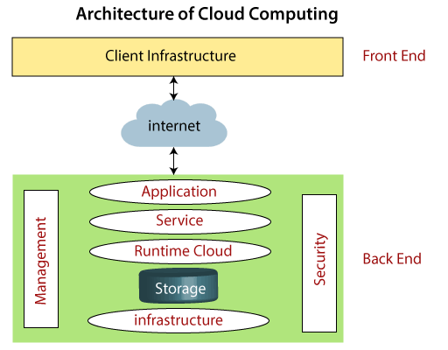

**2 ) IAAS :-**

Infrastructure as a Service (IaaS) is a cloud computing model that provides virtualized computing resources over the internet. In this model, instead of owning physical hardware, users can rent virtual machines, storage, and networking components from a cloud provider on a pay-as-you-go basis. IaaS offers a flexible and scalable solution, allowing businesses to avoid the costs and complexities associated with managing and maintaining their own infrastructure. With IaaS, users have control over their operating systems, applications, and development frameworks, while the cloud provider is responsible for managing the infrastructure components. This model is well-suited for businesses seeking to outsource their infrastructure needs and leverage cloud-based resources to support their IT operations.

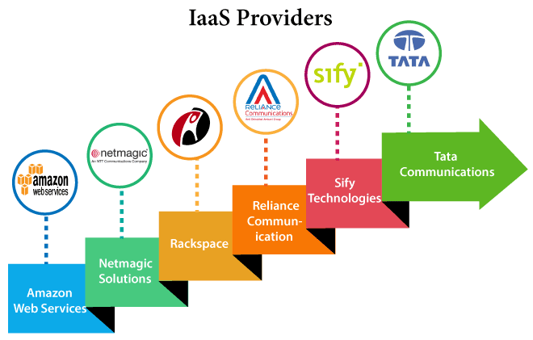

**IaaS provider provides the following services -**

Compute: Computing as a Service includes virtual central processing units and virtual main memory for the Vms that is provisioned to the end- users.

Storage: IaaS provider provides back-end storage for storing files.

Network: Network as a Service (NaaS) provides networking components such as routers, switches, and bridges for the Vms.

Load balancers: It provides load balancing capability at the infrastructure layer.

## Advantages of IaaS cloud computing layer

There are the following advantages of IaaS computing layer -

****1. Shared infrastructure****

IaaS allows multiple users to share the same physical infrastructure.

****2. Web access to the resources****

Iaas allows IT users to access resources over the internet.

****3. Pay-as-per-use model****

IaaS providers provide services based on the pay-as-per-use basis. The users are required to pay for what they have used.

****4. Focus on the core business****

IaaS providers focus on the organization's core business rather than on IT infrastructure.

****5. On-demand scalability****

On-demand scalability is one of the biggest advantages of IaaS. Using IaaS, users do not worry about to upgrade software and troubleshoot the issues related to hardware components.

## Disadvantages of IaaS cloud computing layer

****1. Security****

Security is one of the biggest issues in IaaS. Most of the IaaS providers are not able to provide 100% security.

****2. Maintenance & Upgrade****

Although IaaS service providers maintain the software, but they do not upgrade the software for some organizations.

****3. Interoperability issues****

It is difficult to migrate VM from one IaaS provider to the other, so the customers might face problem related to vendor lock-in.

1. **AWS:-**

AWS stands for[Amazon Web Services](https://www.geeksforgeeks.org/aws-tutorial/), It is an expanded cloud computing platform provided by [Amazon](https://www.geeksforgeeks.org/amazon-interview-questions/)Company. AWS provides a wide range of services with a pay-as-per-use pricing model over the Internet such as Storage, Computing power,[Databases](https://www.geeksforgeeks.org/what-is-database/), [Machine Learning](https://www.geeksforgeeks.org/ml-machine-learning/) services, and much more. AWS facilitates for both businesses and individual users with effectively hosting the applications, storing the data securely, and making use of a wide variety of tools and services improving management flexibility for IT resources.

**History Of AWS**

Then providing[Simple Storage Service (Amazon S3)](https://www.geeksforgeeks.org/introduction-to-aws-simple-storage-service-aws-s3/) revolutionized with scalable management of Storage. Coming up with effective compute and storage services and providing them rental basis helped many startup companies and users with the cost of manual Hardware Infrasture setup. Introducing the concept of [serverless computing](https://www.geeksforgeeks.org/serverless-computing/) with [AWS lambda](https://www.geeksforgeeks.org/introduction-to-aws-lambda/)services enhanced its business globally. It came up with services like [Elastic Beanstalk](https://www.geeksforgeeks.org/introduction-to-aws-elastic-beanstalk/)made the deployment of applications much easier bringing large audiences. AWS always came with diverse array of services offering with technical innovations, updated services with current trends. AWS has emerged as a powerhouse in the world of[Cloud Computing.](https://www.geeksforgeeks.org/cloud-computing/)

1. **AWS Services:-**

Top AWS Services

In the rapid revolution of Cloud Computing, AWS facilitates with wide variety of services respect to the fields and needs. The following are the top AWS services that are in wide usage:

**[Amazon EC2(Elastic Compute Cloud)](https://www.geeksforgeeks.org/what-is-elastic-compute-cloud-ec2/):** It provides the Scalable computing power via cloud allowing the users to run applications and manage the workloads over their remotely.

**[Amazon S3 (Simple Storage Service ):](https://www.geeksforgeeks.org/introduction-to-aws-simple-storage-service-aws-s3/)** It offers scalable object Storage as a Service with high durability for storing and retrieving any amount of data.

**[AWS Lambda:](https://www.geeksforgeeks.org/introduction-to-aws-lambda/)**It is a service in Serverless Architecture with Function as a Service facilitating serverless computing i.e., running the code on response to the events, the background environment management of servers is handled by aws automatically. It helps the developers to completely focus on the logic of code build.

**[Amazon RDS (Relational Database Service)](https://www.geeksforgeeks.org/amazon-rds-introduction-to-amazon-relational-database-system/):** This is an aws service that simplifies the management of database providing high available relational databases in the cloud.

**[Amazon VPC (Virtual Private Cloud):](https://www.geeksforgeeks.org/amazon-vpc-introduction-to-amazon-virtual-cloud/)**It enables the users to create isolated networks with option of public and private expose within the AWS cloud, providing safe and adaptable configurations of their resources.

1. **EC 2 Services:-**

[Amazon Web service](https://www.geeksforgeeks.org/introduction-to-amazon-web-services/) offers EC2 which is a short form of Elastic Compute Cloud (ECC) it is a cloud computing service offered by the Cloud Service Provider AWS. You can deploy your applications in EC2 servers without any worrying about the underlying infrastructure. You configure the EC2-Instance in a very secure manner by using the VPC, [Subnets,](https://www.geeksforgeeks.org/amazon-vpc-introduction-to-amazon-virtual-cloud/)and [Security groups.](https://www.geeksforgeeks.org/what-is-security-group-in-aws-and-how-to-create-it/) You can scale the configuration of the EC2 instance you have configured based on the demand of the application by attaching the autoscaling group to the EC2 instance. You can scale up and scale down the instance based on the incoming traffic of the application.

Use Cases of Amazon EC2 (Elastic Compute Cloud)

1. Deploying Application: In the AWS EC2 instance, you can deploy your application like .jar,.war, or .ear application without maintaining the underlying infrastructure.
2. Scaling Application: Once you deployed your web application in the EC2 instance know you can scale your application based upon the demand you are having by scaling the AWS EC2-Instance.

3) Deploying The ML Models: You can train and deploy your ML models in the EC2-instance because it offers up to 400 Gbps), and storage services purpose-built to optimize the price performance for ML projects.

4 ) Hybrid Cloud Environment: You can deploy your web application in EC2-Instance and you can connect to the database which is deployed in the on-premises servers.

5 ) Cost-Effective: Amazon EC2-instance is cost-effective so you can deploy your gaming application in the Amazon EC2-Instances

The AWS EC2 Instance Types are as follows:

1. General Purpose Instances
2. Compute Optimized Instances
3. Memory-Optimized Instances

4. Storage Optimized Instances

5. Accelerated Computing Instances

--------------------------------------------------------------------------